Day 1: Introduce and Review
Grade: 2nd Grade |  |  | Subject: Science
Materials: Books “Properties of Matter” and “Solids, Liquids, and Gase” |  |  | Technology Needed: None
Instructional Strategies:  ð Direct instruction  ð Guided practice  ð Socratic Seminar  ð Learning Centers  ð Lecture  ð Technology integration  ð Other (list) |  | ð Peer teaching/collaboration/  cooperative learning  ð Visuals/Graphic organizers  ð PBL  ð Discussion/Debate  ð Modeling | Guided Practices and Concrete Application:
 |  |  | ð Large group activity  ð Independent activity  ð Pairing/collaboration  ð Simulations/Scenarios  ð Other (list)  Explain: | ð Hands-on  ð Technology integration  ð Imitation/Repeat/Mimic
Standard(s)  Standard: 2-PS1-1:Plan and conduct an investigation to describe and classify kinds of materials by their observable properties |  |  | Differentiation  Below Proficiency: We will review the whole concept of solids, liquids and gases. This will relay the foundation of understanding for all students, especially the lower level students. They apply the information learned with the 3-2-1 scavenger hunt.  Above Proficiency: After contributing within the reviewed guided instruction, the above level students will have the opportunity to apply knowledge by identifying objects around the room. If the 3-2-1 is not challenging enough, they could do a 4-3-2 or a 5-4-3  Approaching/Emerging Proficiency: The review and then application of the lesson allows on level learners to review and approach the activity on their pace and understanding.  Modalities/Learning Preferences:  Visual, auditory, tactile and kinesthetic
Objective(s)

TSW recall information of solids, liquids and gases and classify examples during discussion.
TSW identify objects around the room as solids, liquids, and gases.

Bloom’s Taxonomy Cognitive Level:
Knowledge: recall Comprehension: classify
Application: identify
Classroom Management- (grouping(s), movement/transitions, etc.)  For movement, students will go around the room and find a minimum of 3 solids, 2 liquids, and 1 gas and fill out their worksheet they will have. |  |  | Behavior Expectations- (systems, strategies, procedures specific to the lesson, rules and expectations, etc.)  Voice level 0 when the teacher is talking. Voice level 1 when turn and talk discussion. Voice level 1 when completing the 3-2-1 activity.
Minutes | Procedures
1 min | Set-up/Prep:  Hand out worksheets to students
10 min | Engage: (opening activity/ anticipatory Set – access prior learning / stimulate interest /generate questions, etc.)  Read aloud book to access prior knowledge and stimulate interest. Show students poster; do a whole group discussion, as well as peer to peer turn-and-talks with questions.  “What is a solid? What is a liquid? What is a gas? What would (display object) be? Think, pair, share.”
10 | Explain: (concepts, procedures, vocabulary, etc.)  Vocab: Solid-firm and stable in shape; not liquid or fluid. Liquid-a substance that flows freely but is of constant volume, having a consistency like that of water or oil. Gas-an airlike fluid substance which expands freely to fill any space available  Students will walk around the classroom and look for 3 solids, 2 liquids, and 1 gas and complete this task in a level 1 voice.
15 | Explore: (independent, concrete practice/application with relevant learning task -connections from content to real-life experiences, reflective questions- probing or clarifying questions)  To connect to real-life experience, students will find objects around the classroom that is either a solid, liquid, or gas. To lead into the discussion tomorrow and for the students to reflect on their knowledge, after they find their objects around the classroom students will be asked, “how did you know that was a solid (liquid or gas)?”
5 | Review (wrap up and transition to next activity):  On a sticky note, students can pick one object they chose from their worksheet and explain one reason how they knew it was it was. Tell them to think about the different characteristics of the object, how does it feel, how does it look, etc.
Formative Assessment: (linked to objectives)  Progress monitoring throughout lesson- clarifying questions, check-  in strategies, etc.  While they are walking around looking for their objects, one can ask what they have for some example and ask why they chose that certain object. Asking “what would this object be considered and why?” and “what makes this object different than this one based on the properties?”  Consideration for Back-up Plan:  As a backup plan, we could pick different objects around the classroom as a group and discuss properties and characteristics together and they can fill in their worksheet. |  |  | Summative Assessment (linked back to objectives)  End of lesson:  Students will hand in their worksheet at the end of the lesson so the teacher can check if they have a good overall idea of some examples of solids, liquids, and gases.  If applicable- overall unit, chapter, concept, etc.:  At the end of the unit, the students will perform a kahoot assessment to show their understanding.
Reflection (What went well? What did the students learn? How do you know? What changes would you make?):

Grade: 2nd Grade |  |  | Subject: Science
Materials: teacher would bring different objects to show the class about the different properties, along with a chart for the class to fill in.  First set of objects discussed as a whole class: sandpaper, a key, and a basketball  Second set of objects that will be placed in each group: spoon, yarn, and a rock (smooth or hard) |  |  | Technology Needed: Show a video on different characteristics on solids, liquids, and gases.https://www.youtube.com/watch?v=C33WdI64FiY&t=68s
Instructional Strategies:  ð Direct instruction  ð Guided practice  ð Socratic Seminar  ð Learning Centers  ð Lecture  ð Technology integration  ð Other (list) |  | ð Peer teaching/collaboration/  cooperative learning  ð Visuals/Graphic organizers  ð PBL  ð Discussion/Debate  ð Modeling | Guided Practices and Concrete Application:
 |  |  | ð Large group activity  ð Independent activity  ð Pairing/collaboration  ð Simulations/Scenarios  ð Other (list)  Explain: | ð Hands-on  ð Technology integration  ð Imitation/Repeat/Mimic
Standard(s)  Standard: 2-PS1-1:Plan and conduct an investigation to describe and classify kinds of materials by their observable properties |  |  | Differentiation  Below Proficiency: Instead of naming 3 characteristics, students can just name 2 for each one.  Above Proficiency: Instead of naming 3 characteristics, students can name 4 or 5 for each one.  Approaching/Emerging Proficiency: The students will practice naming the different characteristics of different objects.  Modalities/Learning Preferences: Visual
Objective(s)
Students will differentiate between the characteristics of solids, liquids, and gases by observing the objects. How does it feel or what does it look like?

Bloom’s Taxonomy Cognitive Level: Differentiate
Classroom Management- (grouping(s), movement/transitions, etc.)  Students will be put in groups or pairs after we talk about different characteristics and properties of a few objects in the classroom. There will be 3 objects placed up in front of the room and groups are to describe each object (3 characteristics for each). High flyers will be put with low flyers. Students are to sit at their desks.. |  |  | Behavior Expectations- (systems, strategies, procedures specific to the lesson, rules and expectations, etc.)  When in groups/pairs students are to use voice level 1.
Minutes | Procedures
3 | Set-up/Prep:  Set out the different objects and get the chart ready.
5/7 | Engage: (opening activity/ anticipatory Set – access prior learning / stimulate interest /generate questions, etc.)  Students will be shown a video. As a class we will then review what a solid, liquid, and gas are. Then ask the questions, “what are some characteristics that made you sure it was either a solid, liquid or gas?”. Go into explaining the different characteristics of a solid (hard, soft, rough, pointy, etc.), liquid, and gas.
15 | Explain: (concepts, procedures, vocabulary, etc.)  Vocab: review the three words they covered the day before. Students will watch the video as a class, then discuss what they learned. The teacher will then show objects to the class and will talk about specific characteristics about each one. After this is talked about as a class, new 3 objects are to be placed at each pod or with each group. Students will get into groups and talk about the different characteristics of each object. Each student will be given a chart to fill out different characteristics of each object or just have the students write on a piece of paper. A chart will be made and put in the front of the class so after the groups have their characteristics ready the class will discuss it together and put it on the chart.
7 | Explore: (independent, concrete practice/application with relevant learning task -connections from content to real-life experiences, reflective questions- probing or clarifying questions)  Students will think of the different characteristics for the objects with their group members. There can be some examples of different characteristics on the board if wanted. They will each have to write it out on a piece of paper and hand it in once we fill in the chart as a class.
3/5 | Review (wrap up and transition to next activity):  Tell the students that they will have to bring an object from home to discuss as a class tomorrow. Hand out the worksheet they will fill in at home then bring to school in 2 days. Go through worksheet together and do an example.
Formative Assessment: (linked to objectives)  Progress monitoring throughout lesson- clarifying questions, check-  in strategies, etc.  Walk around to groups and pick an object. Talk about that object with that group, ask questions about how they knew it was what or ask what characteristics they have so far.  Consideration for Back-up Plan:  Do more examples as a class instead of in groups. Otherwise the teacher can do more examples with the students who seem to be confused and the others can go in pairs and write it out on a piece of paper on their own. |  |  | Summative Assessment (linked back to objectives)  End of lesson: Students are to write down their thoughts on a chart that will be handed out by the teacher or students can just use a piece of paper.  If applicable- overall unit, chapter, concept, etc.:  At the end of the unit, the students will perform a kahoot assessment to show their understanding.
Reflection (What went well? What did the students learn? How do you know? What changes would you make?):

Grade: 2nd Grade |  |  | Subject: Science
Materials: |  |  | Technology Needed: Video https://www.youtube.com/watch?v=qYzjg5nRMOg
Instructional Strategies:  ð Direct instruction  ð Guided practice  ð Socratic Seminar  ð Learning Centers  ð Lecture  ð Technology integration  ð Other (list) |  | ð Peer teaching/collaboration/  cooperative learning  ð Visuals/Graphic organizers  ð PBL  ð Discussion/Debate  ð Modeling | Guided Practices and Concrete Application:
 |  |  | ð Large group activity  ð Independent activity  ð Pairing/collaboration  ð Simulations/Scenarios  ð Other (list)  Explain: | ð Hands-on  ð Technology integration  ð Imitation/Repeat/Mimic
Standard(s)  2-PS1-1:Plan and conduct an investigation to describe and classify kinds of materials by their observable properties |  |  | Differentiation  Below Proficiency: Students will get to work with emerging and above proficiency learners to problem solve at each station.  Above Proficiency: Students will get to work with below and emerging proficiency learners to practice relaying information as a “teacher” to further their understanding.  Approaching/Emerging Proficiency: The students will get to explore the objects at each station to better their understanding.  Modalities/Learning Preferences:  Visual, auditory, tactile, kinesthetic
Objective(s)
TSW work collaboratively to analyze and categorize objects at each station.

Bloom’s Taxonomy Cognitive Level:
Analysis: analyze, categorize.
Classroom Management- (grouping(s), movement/transitions, etc.)  The students will work in groups of 4 or 5 at each station. Various leveled learners will be in each group. The students will rotate clockwise to each station after the teacher signals transition. |  |  | Behavior Expectations- (systems, strategies, procedures specific to the lesson, rules and expectations, etc.)  Expectations: Respectful hands, voice level 1 or 2. Students will fill out sheets with groups while discussing and observing properties.
Minutes | Procedures
5 | Set-up/Prep:  Place objects from kit on 4 table stations. Place technology (laptops, chromebooks, iPads) on station 5.  Station 1: Scissors and glue sticks  Stations 2, 3, and 4: 1 button, 1 stress ball, 1 nail file, 1 dish cloth, 1 letter block, 1 book, 1 magnet and 1 foam brick. Teacher will provide one book at each station.  Station 5 chromebooks ready, opened to the weblink.
3 | Engage: (opening activity/ anticipatory Set – access prior learning / stimulate interest /generate questions, etc.)  “Around the room, I have set up five different stations with various objects for you to observe for their properties. We will be working in groups of four. I want you to work within your group to fill out each sheet within your packet to document your observations.”
3 | Explain: (concepts, procedures, vocabulary, etc.)  “This is the packet you will fill out, page one is with station 1; page 2 is with station 2, page 3 is with station 3 and so on.”  “At station 1 you will be cutting and gluing solids, liquids and gasses on your sheet.”  “At station 2 you will be sorting the objects by weight in categories of heavy or light; you may use the scale to weigh the objects.”  “At station 3 you will be sorting by texture in categories of smooth or rough.”  “At station 4 you will be sorting objects by size in categories of small or large.”  “At station 5 you will be watching a video about observable properties.”  “You will be discussing with your group with a voice level 1 or 2 as you observe and fill out your packet.”
30 min | Explore: (independent, concrete practice/application with relevant learning task -connections from content to real-life experiences, reflective questions- probing or clarifying questions)  Assign students to groups at each station. Teacher will float around the classroom to observe students discussing. Ask prompting questions:  How did you know the was a solid/liquid/gas?  How did you know this was heavy/light?  How did you know this was rough/smooth?
Review (wrap up and transition to next activity):
“Please hand in your packets as we head to recess.”
“Remember for tomorrow, I want each of you to find a small object from home that you could bring to class for your peers to observe. Take this answer key and once you find your object fill it out; it will be the answer key for your peers. When we have science tomorrow you will be observing each other’s objects. Make sure it is school appropriate or you will not participate.”
Formative Assessment: (linked to objectives)  Progress monitoring throughout lesson- clarifying questions, check-  in strategies, etc.  Floating around the classroom asking prompting questions.  Consideration for Back-up Plan:  The teacher can model each station more in depth and then lead a group discussion. |  |  | Summative Assessment (linked back to objectives)  End of lesson:  Each student will hand in their packet they filled out from each station.  If applicable- overall unit, chapter, concept, etc.:  At the end of the unit, the students will perform a kahoot assessment to show their understanding.
Reflection (What went well? What did the students learn? How do you know? What changes would you make?):

Grade: 2nd |  |  | Subject: Science
Materials: sheet to fill out |  |  | Technology Needed: none
Instructional Strategies:  ð Direct instruction  ð Guided practice  ð Socratic Seminar  ð Learning Centers  ð Lecture  ð Technology integration  ð Other (list) |  | ð Peer teaching/collaboration/  cooperative learning  ð Visuals/Graphic organizers  ð PBL  ð Discussion/Debate  ð Modeling | Guided Practices and Concrete Application:
 |  |  | ð Large group activity  ð Independent activity  ð Pairing/collaboration  ð Simulations/Scenarios  ð Other (list)  Explain: | ð Hands-on  ð Technology integration  ð Imitation/Repeat/Mimic
Standard(s)  Standard: 2-PS1-1:Plan and conduct an investigation to describe and classify kinds of materials by their observable properties |  |  | Differentiation  Below Proficiency: Practices identifying observable properties of different objects for a variety of exposure. Allowing time at the end of activity to recheck observations.  Above Proficiency: Students who finish observing the object prior to rotation within group will write a sentence or two to briefly describe the object.  Approaching/Emerging Proficiency: The students will practice observing the properties and will stretch their understanding by trying to write a sentence describing the object.  Modalities/Learning Preferences:  Visual, tactile hands-on, kinesthetic movement
Objective(s)
TSW identify the observable properties of their peer’s objects.

Bloom’s Taxonomy Cognitive Level:
Application: identify Comprehension: demonstrate Synthesis: choosing
Classroom Management- (grouping(s), movement/transitions, etc.)  Students will be grouped in pods of 4 or 5 to observe the properties of each other’s objects.  Students will rotate clockwise in their groups (one in front of each object at a time) allow time for each student to answer; use attention getter (chimes) to signal rotation. |  |  | Behavior Expectations- (systems, strategies, procedures specific to the lesson, rules and expectations, etc.)  Expectations for activity: Voice level 0 when observing properties of objects. Respectful hands (what is appropriate when observing properties of someone’s object i.e. no shaking it, rough-handling it because we do not want it to break).
Minutes | Procedures
0 | Set-up/Prep:  None.
3 | Engage: (opening activity/ anticipatory Set – access prior learning / stimulate interest /generate questions, etc.)  “With a voice level 0, please take out your objects from home and your answer key. Set you object in the middle of your desk, with the answer key flipped face down beside your object. There should be nothing else on your desk.”  “Let’s quickly discuss, what are examples of observable properties?”
5 | Explain: (concepts, procedures, vocabulary, etc.)  Discuss with class what is appropriate when observing each other’s objects  Examples: Gentle hands (touching, picking up, setting down, not forcefully bending or twisting), being respectful of object choices, etc.  “What we will do is rotate around our groups to fill out our observable properties sheet. If you fill out your object’s properties before the five minutes are up, I want you to write a brief description of the object using the properties you observed. For example, I observed a ball; I could write: this ball is smooth, large but light. ”
20-25 | Explore: (independent, concrete practice/application with relevant learning task -connections from content to real-life experiences, reflective questions- probing or clarifying questions)  Direct students to begin observing the object. Have them rotate every 5 minutes around their pod.
3 | Review (wrap up and transition to next activity):  “With our voices still at a level 0 either hand in your sheet, or go back to check over any objects that you need to double check.”
Formative Assessment: (linked to objectives)  Progress monitoring throughout lesson- clarifying questions, check- in strategies, etc.  Floating around the classroom and use prompting questions for students who are struggling to encourage their thinking process.  Consideration for Back-up Plan:  If students struggle, turn it into a small group activity where students work in their pods to identify observable properties |  |  | Summative Assessment (linked back to objectives)  End of lesson:  The sheet where the students kept track of their pod’s objects will serve as summative assessment to demonstrate their level of understanding of observable properties.  If applicable- overall unit, chapter, concept, etc.:  At the end of the unit, the students will perform a kahoot assessment to show their understanding.
Reflection (What went well? What did the students learn? How do you know? What changes would you make?):

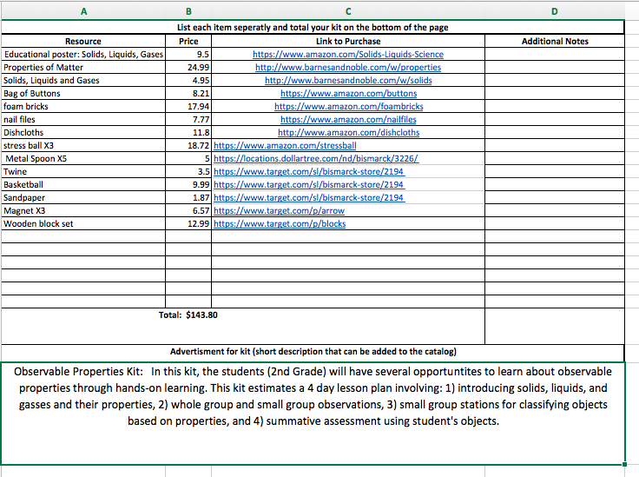

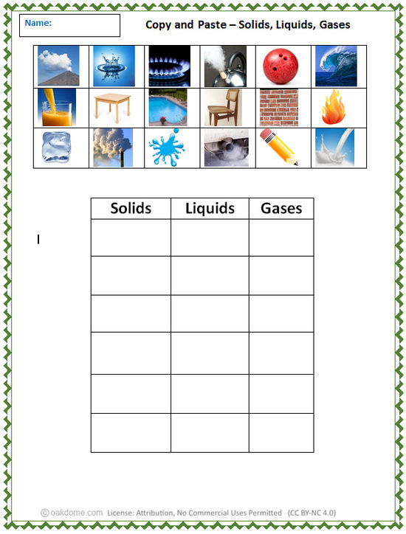

Station 2
Light Heavy
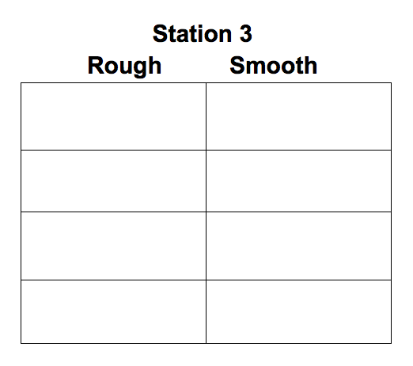
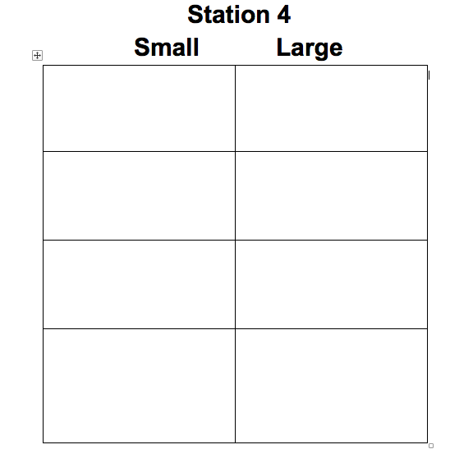

Day 4
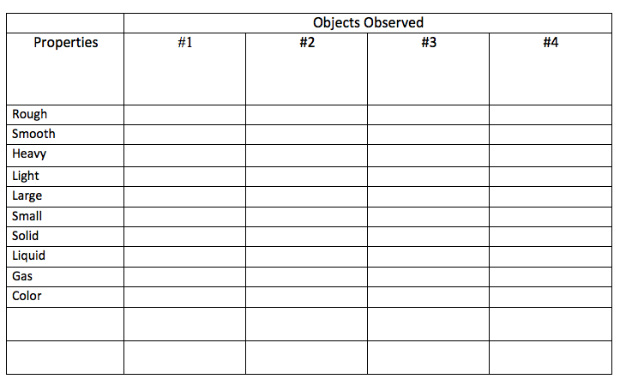
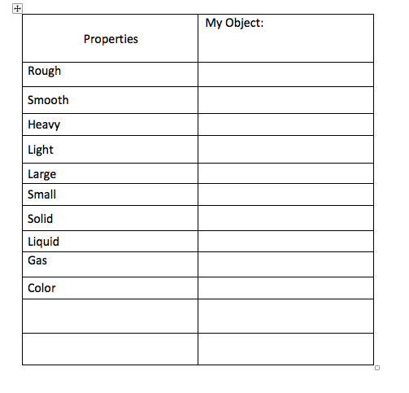
Name: _____________ (Day 1 Worksheet)

3 Solids: 2 Liquids: 1 Gas:

1. 1. 1.

2. 2.

3.

Name: _____________________________________ Day 2 worksheet
List characteristics of objects:

Object #1____________ | Object #2____________ | Object #3____________

